# CONTENT BEYOND SYLLABUS IMPLEMENTATION OF REMOTE COMMAND EXECUTION (RCE)

**AIM**

To implement Remote Command Execution (RCE).

# ALGORITHM

**Client**

1. Establish a connection between the Client and Server. Socket client=new Socket("127.0.0.1",6555);
2. Create instances for input and output streams.

Print Stream ps=new Print Stream(client.getOutputStream());

1. BufferedReaderbr=newBufferedReader(newInputStreamReader(System.in));
2. Enter the command in Client Window. Send themessage to its output str=br.readLine();

ps.println(str);

# Server

1. Accept the connection request by the client. ServerSocket server=new ServerSocket(6555); Sockets=server.accept();
2. GettheIPaddressfromitsinputstream. BufferedReaderbr1=newBufferedReader(newInputStreamReader(s.getInputStream())); ip=br1.readLine();
3. During runtime execute the process Runtime r=Runtime.getRuntime(); Process p=r.exec(str);

# PROGRAM

**Client**

import java.io.*; import java.net.*; classclientRCE

{

public static void main(String args[]) throws IOException

{

try

{

String str;Socket client=new Socket("127.0.0.1",6555); PrintStreamps=new PrintStream(client.getOutputStream());

BufferedReaderbr=new BufferedReader(new InputStreamReader(System.in)); System.out.println("\t\t\t\tCLIENT WINDOW\n\n\t\tEnterTheCommand:"); str=br.readLine();

ps.println(str);

}

catch(IOException e)

{

System.out.println("Error"+e); }

}

}

# Server

import java.io.*; import java.net.*; classserverRCE

{

public static void main(String args[]) throws IOException

{

try

{

String str;

ServerSocket server=new ServerSocket(6555); Socket s=server.accept();

BufferedReaderbr=new BufferedReader(new InputStreamReader(s.getInputStream())); str=br.readLine();

Runtime r=Runtime.getRuntime(); Process p=r.exec(str);

}

catch(IOException e)

{

System.out.println("Error"+e);

}

}

}

# OUTPUT

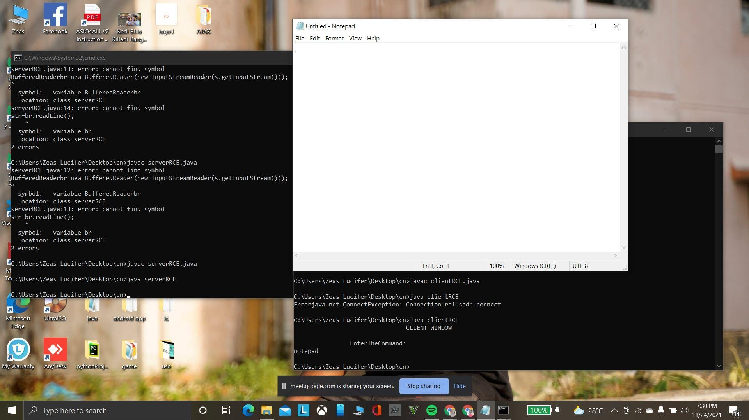

**RESULT**

Thus the implementation RCE is done & executed successfully.